**PRUEBAS 6749**

PARA REALIZAR LA PRUEBA DE ESTE CASO EN LA INTEFAZ DE CONTROL REINTEGRO, TOMAREMOS EL DIA 4 DE MAYO. MOSTRAREMOS LAS EVIDENCIAS COMO SE ENVIO LA TRAMA ESE MOMENTO A SAP Y COMO SE GENERA ACTUALMENTE.

REVERSAMOS REGISTROS CONTABLES

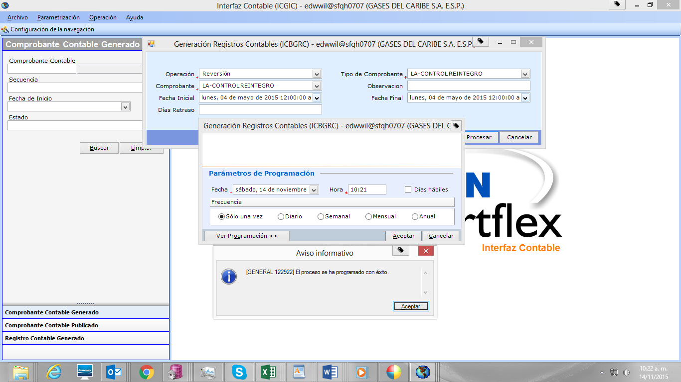

REVERSAMOS HECHOS ECONOMICOS

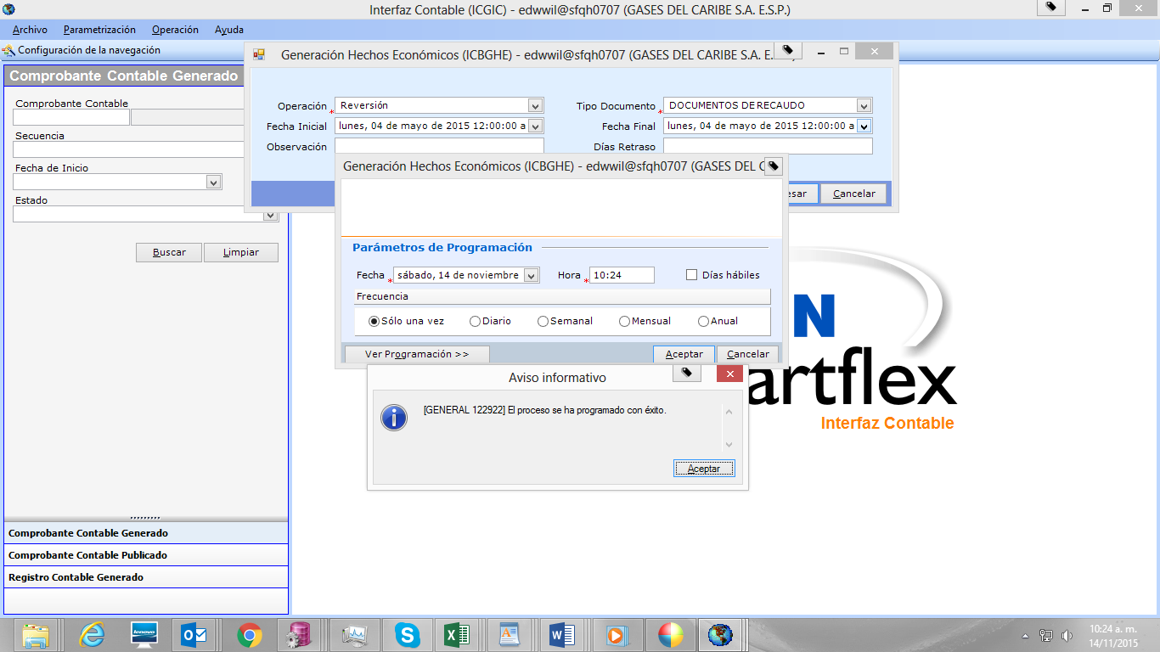

GENERAMOS HECHOS

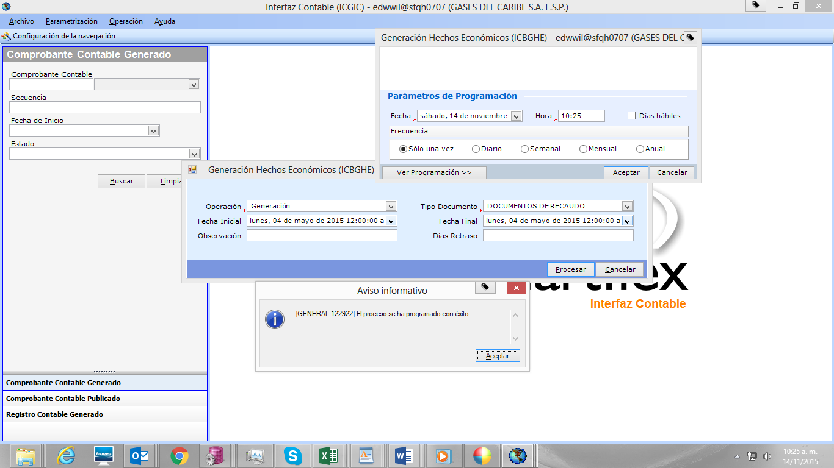

GENERAMOS REGISTROS CONTABLES PARA EL DIA 4 DE MAYO.

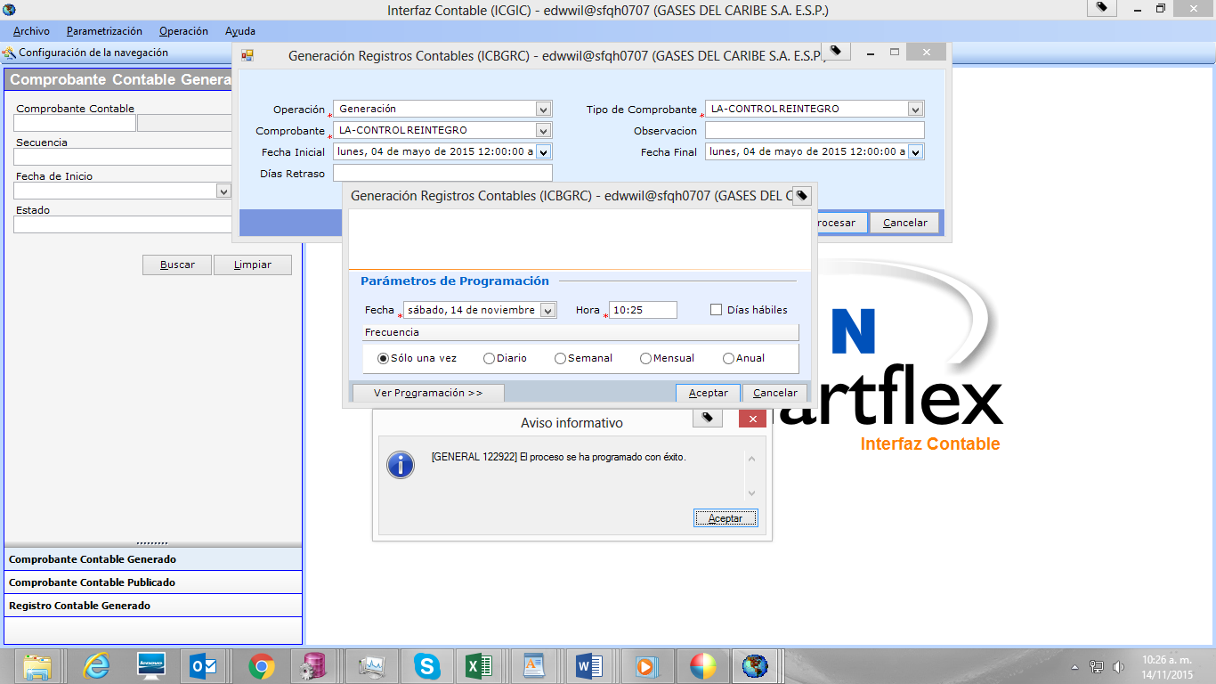

GENERAMOS LA NUEVA TRAMA

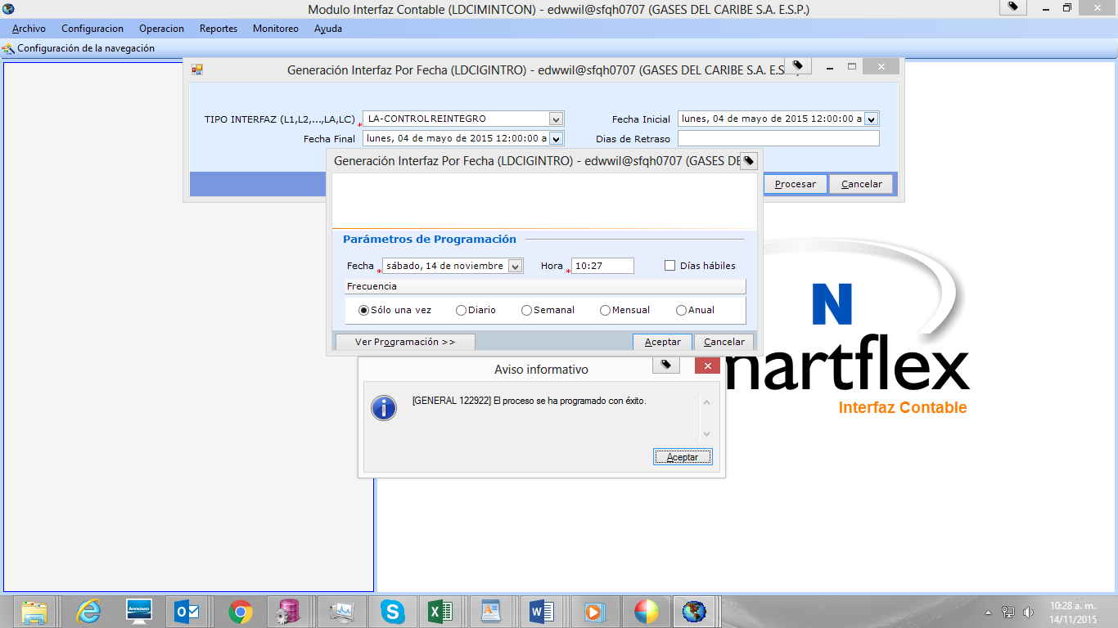

REVISAMOS LA TRAMA QUE SE ENVIO EN PRODUCCION A SAP 4238 Y LA NUEVA GENERADA 5109.

|  |  |  |  |  |  |  |  |  |  |  |
| --- | --- | --- | --- | --- | --- | --- | --- | --- | --- | --- |
| **TRAMA** | **DCTO** | **CUENTA** | **DEBITO** | **CREDITO** |  | **TRAMA** | **DCTO** | **CUENTA** | **DEBITO** | **CREDITO** |
| 4238 | 1 | 1110055011 | 105.108 |  |  | 5109 | 1 | 1110055011 | 105.108 |  |
| 4238 | 1 | 1110055011 | 160.057 |  |  | 5109 | 1 | 1110055011 | 160.057 |  |
| 4238 | 1 | 1110055011 | 375.031 |  |  | 5109 | 1 | 1110055011 | 375.031 |  |
| 4238 | 1 | 1110055011 | 430.211 |  |  | 5109 | 1 | 1110055011 | 430.211 |  |
| 4238 | 1 | 1110055011 | 432.468 |  |  | 5109 | 1 | 1110055011 | 432.468 |  |
| 4238 | 1 | 1110055011 | 717.225 |  |  | 5109 | 1 | 1110055011 | 717.225 |  |
| 4238 | 1 | 1110055011 | 1.190.521 |  |  | 5109 | 1 | 1110055011 | 1.031.365 |  |
| 4238 | 1 | 1110055011 | 1.824.419 |  |  | 5109 | 1 | 1110055011 | 1.190.521 |  |
| 4238 | 1 | 1110055011 | 1.941.043 |  |  | 5109 | 1 | 1110055011 | 1.824.419 |  |
| 4238 | 1 | 1110055011 | 2.399.234 |  |  | 5109 | 1 | 1110055011 | 1.941.043 |  |
| 4238 | 1 | 1110055011 | 2.659.096 |  |  | 5109 | 1 | 1110055011 | 2.399.234 |  |
| 4238 | 1 | 1110055011 | 2.769.485 |  |  | 5109 | 1 | 1110055011 | 2.659.096 |  |
| 4238 | 1 | 1110055011 | 3.220.670 |  |  | 5109 | 1 | 1110055011 | 2.769.485 |  |
| 4238 | 1 | 1110055011 | 3.458.063 |  |  | 5109 | 1 | 1110055011 | 3.220.670 |  |
| 4238 | 1 | 1110055011 | 4.358.166 |  |  | 5109 | 1 | 1110055011 | 3.458.063 |  |
| 4238 | 1 | 1110055011 | 9.840.542 |  |  | 5109 | 1 | 1110055011 | 4.358.166 |  |
| 4238 | 1 | 1110055041 | 48.494 |  |  | 5109 | 1 | 1110055011 | 9.840.542 |  |
| 4238 | 1 | 1110055041 | 257.000 |  |  | 5109 | 1 | 1110055041 | 48.494 |  |
| 4238 | 1 | 1110055041 | 280.003 |  |  | 5109 | 1 | 1110055041 | 257.000 |  |
| 4238 | 1 | 1110055041 | 320.000 |  |  | 5109 | 1 | 1110055041 | 280.003 |  |
| 4238 | 1 | 1110055041 | 638.026 |  |  | 5109 | 1 | 1110055041 | 320.000 |  |
| 4238 | 1 | 1110055041 | 644.280 |  |  | 5109 | 1 | 1110055041 | 638.026 |  |
| 4238 | 1 | 1110055041 | 1.031.365 |  |  | 5109 | 1 | 1110055041 | 644.280 |  |
| 4238 | 1 | 1110055041 | 2.852.847 |  |  | 5109 | 1 | 1110055041 | 2.852.847 |  |
| 4238 | 1 | 1110065021 | 2.547.500 |  |  | 5109 | 1 | 1110065021 | 2.547.500 |  |
| 4238 | 1 | 1470650100 |  | 48.494 |  | 5109 | 1 | 1470650100 |  | 48.494 |
| 4238 | 1 | 1470650100 |  | 105.108 |  | 5109 | 1 | 1470650100 |  | 105.108 |
| 4238 | 1 | 1470650100 |  | 280.003 |  | 5109 | 1 | 1470650100 |  | 280.003 |
| 4238 | 1 | 1470650100 |  | 430.211 |  | 5109 | 1 | 1470650100 |  | 430.211 |
| 4238 | 1 | 1470650100 |  | 432.468 |  | 5109 | 1 | 1470650100 |  | 432.468 |
| 4238 | 1 | 1470650100 |  | 632.031 |  | 5109 | 1 | 1470650100 |  | 632.031 |
| 4238 | 1 | 1470650100 |  | 638.026 |  | 5109 | 1 | 1470650100 |  | 638.026 |
| 4238 | 1 | 1470650100 |  | 644.280 |  | 5109 | 1 | 1470650100 |  | 644.280 |
| 4238 | 1 | 1470650100 |  | 717.225 |  | 5109 | 1 | 1470650100 |  | 717.225 |
| 4238 | 1 | 1470650100 |  | 1.031.365 |  | 5109 | 1 | 1470650100 |  | 1.031.365 |
| 4238 | 1 | 1470650100 |  | 1.190.521 |  | 5109 | 1 | 1470650100 |  | 1.190.521 |
| 4238 | 1 | 1470650100 |  | 1.824.419 |  | 5109 | 1 | 1470650100 |  | 1.824.419 |
| 4238 | 1 | 1470650100 |  | 1.941.043 |  | 5109 | 1 | 1470650100 |  | 1.941.043 |
| 4238 | 1 | 1470650100 |  | 2.399.234 |  | 5109 | 1 | 1470650100 |  | 2.399.234 |
| 4238 | 1 | 1470650100 |  | 2.547.500 |  | 5109 | 1 | 1470650100 |  | 2.547.500 |
| 4238 | 1 | 1470650100 |  | 2.659.096 |  | 5109 | 1 | 1470650100 |  | 2.659.096 |
| 4238 | 1 | 1470650100 |  | 3.012.904 |  | 5109 | 1 | 1470650100 |  | 3.012.904 |
| 4238 | 1 | 1470650100 |  | 3.089.485 |  | 5109 | 1 | 1470650100 |  | 3.089.485 |
| 4238 | 1 | 1470650100 |  | 3.220.670 |  | 5109 | 1 | 1470650100 |  | 3.220.670 |
| 4238 | 1 | 1470650100 |  | 3.458.063 |  | 5109 | 1 | 1470650100 |  | 3.458.063 |
| 4238 | 1 | 1470650100 |  | 4.358.166 |  | 5109 | 1 | 1470650100 |  | 4.358.166 |
| 4238 | 1 | 1470650100 |  | 9.840.542 |  | 5109 | 1 | 1470650100 |  | 9.840.542 |
| 4238 | 2 | 1110055011 | 802.100 |  |  | 5109 | 2 | 1110055011 | 802.100 |  |
| 4238 | 2 | 1110055011 | 5.065.965 |  |  | 5109 | 2 | 1110055011 | 5.065.965 |  |
| 4238 | 2 | 1110055041 | 1.207.338 |  |  | 5109 | 2 | 1110055041 | 1.207.338 |  |
| 4238 | 2 | 1110065021 | 5.649.600 |  |  | 5109 | 2 | 1110065021 | 5.649.600 |  |
| 4238 | 2 | 1470650100 |  | 802.100 |  | 5109 | 2 | 1470650100 |  | 802.100 |
| 4238 | 2 | 1470650100 |  | 1.207.338 |  | 5109 | 2 | 1470650100 |  | 1.207.338 |
| 4238 | 2 | 1470650100 |  | 5.065.965 |  | 5109 | 2 | 1470650100 |  | 5.065.965 |
| 4238 | 2 | 1470650100 |  | 5.649.600 |  | 5109 | 2 | 1470650100 |  | 5.649.600 |
| 4238 | 3 | 1110055011 | 1.146.547 |  |  | 5109 | 3 | 1110055011 | 1.146.547 |  |
| 4238 | 3 | 1110055011 | 5.647.638 |  |  | 5109 | 3 | 1110055011 | 5.647.638 |  |
| 4238 | 3 | 1470650100 |  | 1.146.547 |  | 5109 | 3 | 1470650100 |  | 1.146.547 |
| 4238 | 3 | 1470650100 |  | 5.647.638 |  | 5109 | 3 | 1470650100 |  | 5.647.638 |
| 4238 | 4 | 1110055011 | 709.000 |  |  | 5109 | 4 | 1110055011 | 709.000 |  |
| 4238 | 4 | 1470650100 |  | 709.000 |  | 5109 | 4 | 1470650100 |  | 709.000 |
| 4238 | 5 | 1110055041 | 248.000 |  |  | 5109 | 5 | 1110055041 | 248.000 |  |
| 4238 | 5 | 1470650100 |  | 248.000 |  | 5109 | 5 | 1470650100 |  | 248.000 |
| 4238 | 6 | 1110055011 | 290 |  |  | 5109 | 6 | 1110055011 | 290 |  |
| 4238 | 6 | 1470650100 |  | 290 |  | 5109 | 6 | 1470650100 |  | 290 |
| **TOTALES** | | | **64.977.332** | **64.977.332** |  | **TOTALES** | | | **64.977.332** | **64.977.332** |

SE ANALIZA Y SE DETERMINA QUE EL DESARROLLO NO ALTERA LOS RESULTADOS CON LA PRIMERA, NO HAY PROBLEMAS CON LA SOLUCION DESARROLLADA.

PARA REALIZAR LA PRUEBA DEL NUMERO DE REGISTROS POR NUMERO DE DOCUMENTO, SE PROCEDE A REALIZAR UNA MODIFICACION AL PAQUETE LDCIPKINTERFAZSAP, PARA QUE HAGA ROMPIMIENTO POR DOCUMENTO CADA 600 REGISTROS, SE HACE ESTA MODIFICACION POR QUE EN LA BASE DE DATOS QH NO HAY UN MES DONDE EL NUMERO DE REGISTROS SOBREPASE LOS 998 QUE ES LO QUE TIENE EL PAQUETE, EN QH HAY DATOS HASTA EL MES DE JUNIO Y DE JULIO EN ADELANTE SE PRESENTO EL INCONVENIENTE.

PARA ESTA PRUEBA TOMAMOS EL MES DE MAYO.

INTERFAZ DE INGRESO

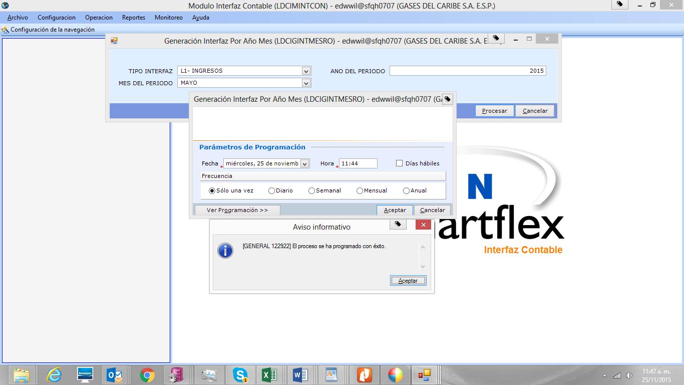

REVISAMOS LOS RESULTADOS OBTENIDOS EN LA PRIMERA INTERFAZ, 4686 Y LA ÚLTIMA GENERADA CON LA CORECCION 5110.

|  |  |  |  |  |  |  |  |  |  |  |  |  |  |  |
| --- | --- | --- | --- | --- | --- | --- | --- | --- | --- | --- | --- | --- | --- | --- |
| **TRAMA** | **DCTO** | **CLA** | **REG** | **CUENTA** | **DEBITO** | **CREDITO** |  | **TRAMA** | **DCTO** | **CLA** | **REG** | **CUENTA** | **DEBITO** | **CREDITO** |
| 5110 | 1 | 1 | 44 | 1407900101 | 21.834 | 366.269 |  | 4686 | 1 | 1 | 44 | 1407900101 | 21.834 | 366.269 |
| 5110 | 1 | 1 | 44 | 1408050101 | 15.386 | 36.054 |  | 4686 | 1 | 1 | 44 | 1408050101 | 15.386 | 36.054 |
| 5110 | 1 | 1 | 44 | 1480230100 | 32.552 | 2.920 |  | 4686 | 1 | 1 | 44 | 1480230100 | 32.552 | 2.920 |
| 5110 | 1 | 1 | 44 | 2425902100 | 333.717 | 18.914 |  | 4686 | 1 | 1 | 44 | 2425902100 | 333.717 | 18.914 |
| 5110 | 1 | 1 | 44 | 2450010300 | 11.561 |  |  | 4686 | 1 | 1 | 44 | 2450010300 | 11.561 |  |
| 5110 | 1 | 1 | 44 | 4810081100 | 24.493 | 15.386 |  | 4686 | 1 | 1 | 44 | 4810081100 | 24.493 | 15.386 |
| 5110 | 2001 | 2 | 592 | 1407902101 | 6.027.474.420 | 209.087.703 |  | 4686 | 2 | 2 | 892 | 1407902101 | 11.468.278.979 | 277.796.521 |
| 5110 | 2001 | 2 | 592 | 1480900200 | 80.559.873 |  |  | 4686 | 2 | 2 | 892 | 1480900200 | 87.879.849 |  |
| 5110 | 2001 | 2 | 592 | 2425902100 | 57.134.173 | 58.632.304 |  | 4686 | 2 | 2 | 892 | 2425902100 | 84.910.974 | 86.669.769 |
| 5110 | 2001 | 2 | 592 | 2425909100 | 71.393.657 | 5.968.313.945 |  | 4686 | 2 | 2 | 892 | 2425909100 | 105.005.698 | 11.381.081.039 |
| 5110 | 2001 | 2 | 592 | 4810081100 |  | 528.171 |  | 4686 | 2 | 2 | 892 | 4810081100 |  | 528.171 |
| 5110 | 2002 | 2 | 300 | 1407902101 | 3.055.065.430 | 68.708.818 |  |  |  |  |  |  |  |  |
| 5110 | 2002 | 2 | 300 | 1480900200 | 7.319.976 |  |  |  |  |  |  |  |  |  |
| 5110 | 2002 | 2 | 300 | 2425902100 | 27.776.801 | 28.037.465 |  |  |  |  |  |  |  |  |
| 5110 | 2002 | 2 | 300 | 2425909100 | 33.612.041 | 3.027.027.965 |  |  |  |  |  |  |  |  |
| 5110 | 3 | 3 | 331 | 1408051101 | 818.533.602 | 48.410.635 |  | 4686 | 3 | 3 | 331 | 1408051101 | 818.533.602 | 48.410.635 |
| 5110 | 3 | 3 | 331 | 1470900100 |  | 3.341 |  | 4686 | 3 | 3 | 331 | 1470900100 |  | 3.341 |
| 5110 | 3 | 3 | 331 | 1480230100 | 11.222.229 |  |  | 4686 | 3 | 3 | 331 | 1480230100 | 11.222.229 |  |
| 5110 | 3 | 3 | 331 | 2425902100 | 10.283.133 | 1.879.857 |  | 4686 | 3 | 3 | 331 | 2425902100 | 10.283.133 | 1.879.857 |
| 5110 | 3 | 3 | 331 | 4325270100 | 26.905.273 | 815.308.686 |  | 4686 | 3 | 3 | 331 | 4325270100 | 26.905.273 | 815.308.686 |
| 5110 | 3 | 3 | 331 | 4810081100 |  | 1.341.718 |  | 4686 | 3 | 3 | 331 | 4810081100 |  | 1.341.718 |
| 5110 | 4 | 4 | 230 | 1408050101 | 817.849.246 | 145.215.488 |  | 4686 | 4 | 4 | 230 | 1408050101 | 817.849.246 | 145.215.488 |
| 5110 | 4 | 4 | 230 | 1480230100 | 20.540.846 |  |  | 4686 | 4 | 4 | 230 | 1480230100 | 20.540.846 |  |
| 5110 | 4 | 4 | 230 | 2425902100 | 119.602.530 | 433.086 |  | 4686 | 4 | 4 | 230 | 2425902100 | 119.602.530 | 433.086 |
| 5110 | 4 | 4 | 230 | 2915030000 | 5.072.112 | 806.119.243 |  | 4686 | 4 | 4 | 230 | 2915030000 | 5.072.112 | 806.119.243 |
| 5110 | 4 | 4 | 230 | 4810081100 |  | 11.296.917 |  | 4686 | 4 | 4 | 230 | 4810081100 |  | 11.296.917 |
| 5110 | 6 | 6 | 16 | 1407900101 | 4.848 | 15.894 |  | 4686 | 6 | 6 | 16 | 1407900101 | 4.848 | 15.894 |
| 5110 | 6 | 6 | 16 | 1480230100 |  | 4.848 |  | 4686 | 6 | 6 | 16 | 1480230100 |  | 4.848 |
| 5110 | 6 | 6 | 16 | 4810081100 | 15.894 |  |  | 4686 | 6 | 6 | 16 | 4810081100 | 15.894 |  |
| 5110 | 7 | 7 | 514 | 1408051101 | 53.101.510.091 | 2.038.357.501 |  | 4686 | 7 | 7 | 514 | 1408051101 | 53.101.510.091 | 2.038.357.501 |
| 5110 | 7 | 7 | 514 | 1470900100 |  | 23.124.766 |  | 4686 | 7 | 7 | 514 | 1470900100 |  | 23.124.766 |
| 5110 | 7 | 7 | 514 | 1480230100 | 79.248.726 | 840.593 |  | 4686 | 7 | 7 | 514 | 1480230100 | 79.248.726 | 840.593 |
| 5110 | 7 | 7 | 514 | 2425902100 | 962.089.467 | 47.580.143 |  | 4686 | 7 | 7 | 514 | 2425902100 | 962.089.467 | 47.580.143 |
| 5110 | 7 | 7 | 514 | 4325270200 | 196.410.325 | 53.016.326.569 |  | 4686 | 7 | 7 | 514 | 4325270200 | 196.410.325 | 53.016.326.569 |
| 5110 | 7 | 7 | 514 | 4810081100 | 188.306 | 13.538.020 |  | 4686 | 7 | 7 | 514 | 4810081100 | 188.306 | 13.538.020 |
| 5110 | 7 | 7 | 514 | 4810470100 | 800.420.677 | 100.000 |  | 4686 | 7 | 7 | 514 | 4810470100 | 800.420.677 | 100.000 |
| 5110 | 8 | 8 | 284 | 1408051101 | 632.688.443 | 48.332.622 |  | 4686 | 8 | 8 | 284 | 1408051101 | 632.688.443 | 48.332.622 |
| 5110 | 8 | 8 | 284 | 1470900100 |  | 53.378 |  | 4686 | 8 | 8 | 284 | 1470900100 |  | 53.378 |
| 5110 | 8 | 8 | 284 | 1480230100 | 5.907.454 | 15.920 |  | 4686 | 8 | 8 | 284 | 1480230100 | 5.907.454 | 15.920 |
| 5110 | 8 | 8 | 284 | 2425902100 | 5.642.033 | 3.631.328 |  | 4686 | 8 | 8 | 284 | 2425902100 | 5.642.033 | 3.631.328 |
| 5110 | 8 | 8 | 284 | 2430152100 | 1.465.700 | 154.888.898 |  | 4686 | 8 | 8 | 284 | 2430152100 | 1.465.700 | 154.888.898 |
| 5110 | 8 | 8 | 284 | 2430152300 | 1.987.311 | 310.182 |  | 4686 | 8 | 8 | 284 | 2430152300 | 1.987.311 | 310.182 |
| 5110 | 8 | 8 | 284 | 2430152400 | 2.100.481 | 262.227.086 |  | 4686 | 8 | 8 | 284 | 2430152400 | 2.100.481 | 262.227.086 |
| 5110 | 8 | 8 | 284 | 2430152500 | 31.229.643 | 211.140.246 |  | 4686 | 8 | 8 | 284 | 2430152500 | 31.229.643 | 211.140.246 |
| 5110 | 8 | 8 | 284 | 4810081100 |  | 421.405 |  | 4686 | 8 | 8 | 284 | 4810081100 |  | 421.405 |
| 5110 | 10 | 10 | 70 | 1407900101 | 15.524.013 | 27.509.487 |  | 4686 | 10 | 10 | 70 | 1407900101 | 15.524.013 | 27.509.487 |
| 5110 | 10 | 10 | 70 | 4395900103 | 27.509.487 | 15.524.013 |  | 4686 | 10 | 10 | 70 | 4395900103 | 27.509.487 | 15.524.013 |
| 5110 | 17 | 17 | 297 | 1408050101 | 870.863.269 | 45.634.778 |  | 4686 | 17 | 17 | 297 | 1408050101 | 870.863.269 | 45.634.778 |
| 5110 | 17 | 17 | 297 | 1480230100 | 37.667.122 | 855 |  | 4686 | 17 | 17 | 297 | 1480230100 | 37.667.122 | 855 |
| 5110 | 17 | 17 | 297 | 2425902100 | 3.187.228 | 1.263.292 |  | 4686 | 17 | 17 | 297 | 2425902100 | 3.187.228 | 1.263.292 |
| 5110 | 17 | 17 | 297 | 4325260500 | 4.780.428 | 858.850.719 |  | 4686 | 17 | 17 | 297 | 4325260500 | 4.780.428 | 858.850.719 |
| 5110 | 17 | 17 | 297 | 4810081100 |  | 10.748.403 |  | 4686 | 17 | 17 | 297 | 4810081100 |  | 10.748.403 |
| 5110 | 19 | 19 | 162 | 1407900101 | 1.311.459.957 | 112.446.704 |  | 4686 | 19 | 19 | 162 | 1407900101 | 1.311.459.957 | 112.446.704 |
| 5110 | 19 | 19 | 162 | 2425902100 | 112.048.970 |  |  | 4686 | 19 | 19 | 162 | 2425902100 | 112.048.970 |  |
| 5110 | 19 | 19 | 162 | 2915030000 | 397.734 | 1.311.459.957 |  | 4686 | 19 | 19 | 162 | 2915030000 | 397.734 | 1.311.459.957 |
| 5110 | 21 | 21 | 12 | 1408051101 | 12.468 | 14.846 |  | 4686 | 21 | 21 | 12 | 1408051101 | 12.468 | 14.846 |
| 5110 | 21 | 21 | 12 | 1480230100 |  | 12.468 |  | 4686 | 21 | 21 | 12 | 1480230100 |  | 12.468 |
| 5110 | 21 | 21 | 12 | 4810081100 | 14.846 |  |  | 4686 | 21 | 21 | 12 | 4810081100 | 14.846 |  |
| 5110 | 22 | 22 | 10 | 1408050101 | 792.000 | 201.828 |  | 4686 | 22 | 22 | 10 | 1408050101 | 792.000 | 201.828 |
| 5110 | 22 | 22 | 10 | 2425902100 | 3.828 |  |  | 4686 | 22 | 22 | 10 | 2425902100 | 3.828 |  |
| 5110 | 22 | 22 | 10 | 4325260600 | 198.000 | 792.000 |  | 4686 | 22 | 22 | 10 | 4325260600 | 198.000 | 792.000 |
| 5110 | 24 | 24 | 121 | 1407901101 | 1.538.188 | 11.016.515 |  | 4686 | 24 | 24 | 121 | 1407901101 | 1.538.188 | 11.016.515 |
| 5110 | 24 | 24 | 121 | 1480230100 | 7.253.235 |  |  | 4686 | 24 | 24 | 121 | 1480230100 | 7.253.235 |  |
| 5110 | 24 | 24 | 121 | 2425902100 | 3.318.460 | 75.070 |  | 4686 | 24 | 24 | 121 | 2425902100 | 3.318.460 | 75.070 |
| 5110 | 24 | 24 | 121 | 4390900110 | 444.820 | 7.938 |  | 4686 | 24 | 24 | 121 | 4390900110 | 444.820 | 7.938 |
| 5110 | 24 | 24 | 121 | 4810081100 |  | 1.455.180 |  | 4686 | 24 | 24 | 121 | 4810081100 |  | 1.455.180 |
| 5110 | 27 | 27 | 277 | 1407901101 | 244.392.554 | 74.959.516 |  | 4686 | 27 | 27 | 277 | 1407901101 | 244.392.554 | 74.959.516 |
| 5110 | 27 | 27 | 277 | 1480230100 | 58.088.610 |  |  | 4686 | 27 | 27 | 277 | 1480230100 | 58.088.610 |  |
| 5110 | 27 | 27 | 277 | 2425902100 | 5.561.370 | 1.826.018 |  | 4686 | 27 | 27 | 277 | 2425902100 | 5.561.370 | 1.826.018 |
| 5110 | 27 | 27 | 277 | 4390900102 | 11.309.536 | 221.338.503 |  | 4686 | 27 | 27 | 277 | 4390900102 | 11.309.536 | 221.338.503 |
| 5110 | 27 | 27 | 277 | 4810081100 |  | 21.228.033 |  | 4686 | 27 | 27 | 277 | 4810081100 |  | 21.228.033 |
| 5110 | 28 | 28 | 213 | 1408050101 | 236.161.270 | 20.418.996 |  | 4686 | 28 | 28 | 213 | 1408050101 | 236.161.270 | 20.418.996 |
| 5110 | 28 | 28 | 213 | 1480230100 | 11.981.576 |  |  | 4686 | 28 | 28 | 213 | 1480230100 | 11.981.576 |  |
| 5110 | 28 | 28 | 213 | 2425902100 | 2.857.999 | 694.119 |  | 4686 | 28 | 28 | 213 | 2425902100 | 2.857.999 | 694.119 |
| 5110 | 28 | 28 | 213 | 4325260400 | 5.579.421 | 230.168.671 |  | 4686 | 28 | 28 | 213 | 4325260400 | 5.579.421 | 230.168.671 |
| 5110 | 28 | 28 | 213 | 4810081100 |  | 5.298.480 |  | 4686 | 28 | 28 | 213 | 4810081100 |  | 5.298.480 |
| 5110 | 30 | 30 | 350 | 1408051101 | 47.034.306 | 5.182.437.544 |  | 4686 | 30 | 30 | 350 | 1408051101 | 47.034.306 | 5.182.437.544 |
| 5110 | 30 | 30 | 350 | 1480230100 | 228.657 | 7.182.757 |  | 4686 | 30 | 30 | 350 | 1480230100 | 228.657 | 7.182.757 |
| 5110 | 30 | 30 | 350 | 2425902100 | 326.243 | 21.529.285 |  | 4686 | 30 | 30 | 350 | 2425902100 | 326.243 | 21.529.285 |
| 5110 | 30 | 30 | 350 | 2430151100 | 5.178.534.238 | 18.238.929 |  | 4686 | 30 | 30 | 350 | 2430151100 | 5.178.534.238 | 18.238.929 |
| 5110 | 30 | 30 | 350 | 4810081100 | 3.348.406 | 83.335 |  | 4686 | 30 | 30 | 350 | 4810081100 | 3.348.406 | 83.335 |
| 5110 | 32 | 32 | 18 | 1406060101 | 64.277 | 98.958 |  | 4686 | 32 | 32 | 18 | 1406060101 | 64.277 | 98.958 |
| 5110 | 32 | 32 | 18 | 1480230100 | 98.418 |  |  | 4686 | 32 | 32 | 18 | 1480230100 | 98.418 |  |
| 5110 | 32 | 32 | 18 | 2425902100 | 540 |  |  | 4686 | 32 | 32 | 18 | 2425902100 | 540 |  |
| 5110 | 32 | 32 | 18 | 4810081100 |  | 64.277 |  | 4686 | 32 | 32 | 18 | 4810081100 |  | 64.277 |
| 5110 | 35 | 35 | 6 | 1408050101 | 4 |  |  | 4686 | 35 | 35 | 6 | 1408050101 | 4 |  |
| 5110 | 35 | 35 | 6 | 2425902100 |  | 4 |  | 4686 | 35 | 35 | 6 | 2425902100 |  | 4 |
| 5110 | 44 | 44 | 2 | 1407901101 |  | 152.700 |  | 4686 | 44 | 44 | 2 | 1407901101 |  | 152.700 |
| 5110 | 44 | 44 | 2 | 2425902100 | 152.700 |  |  | 4686 | 44 | 44 | 2 | 2425902100 | 152.700 |  |
| 5110 | 46 | 46 | 480 | 1408051101 | 10.419.280 | 89.639.625 |  | 4686 | 46 | 46 | 480 | 1408051101 | 10.419.280 | 89.639.625 |
| 5110 | 46 | 46 | 480 | 1470034101 | 300.765.641 |  |  | 4686 | 46 | 46 | 480 | 1470034101 | 300.765.641 |  |
| 5110 | 46 | 46 | 480 | 1470900100 |  | 8.475 |  | 4686 | 46 | 46 | 480 | 1470900100 |  | 8.475 |
| 5110 | 46 | 46 | 480 | 1480230100 | 59.975.294 |  |  | 4686 | 46 | 46 | 480 | 1480230100 | 59.975.294 |  |
| 5110 | 46 | 46 | 480 | 2425902100 | 1.089.913 | 374.388 |  | 4686 | 46 | 46 | 480 | 2425902100 | 1.089.913 | 374.388 |
| 5110 | 46 | 46 | 480 | 4805130201 | 20.373.557 | 301.382.026 |  | 4686 | 46 | 46 | 480 | 4805130201 | 20.373.557 | 301.382.026 |
| 5110 | 46 | 46 | 480 | 4810081100 | 6.358 | 9.420.032 |  | 4686 | 46 | 46 | 480 | 4810081100 | 6.358 | 9.420.032 |
| 5110 | 46 | 46 | 480 | 4810470100 | 8.194.503 |  |  | 4686 | 46 | 46 | 480 | 4810470100 | 8.194.503 |  |
| 5110 | 49 | 49 | 18 | 1408050101 |  | 323.799 |  | 4686 | 49 | 49 | 18 | 1408050101 |  | 323.799 |
| 5110 | 49 | 49 | 18 | 1408051101 | 15.894 |  |  | 4686 | 49 | 49 | 18 | 1408051101 | 15.894 |  |
| 5110 | 49 | 49 | 18 | 2425902100 | 323.799 |  |  | 4686 | 49 | 49 | 18 | 2425902100 | 323.799 |  |
| 5110 | 49 | 49 | 18 | 4810081100 |  | 15.894 |  | 4686 | 49 | 49 | 18 | 4810081100 |  | 15.894 |
| 5110 | 52 | 52 | 60 | 1407904101 | 486.658 | 6.109.695 |  | 4686 | 52 | 52 | 60 | 1407904101 | 486.658 | 6.109.695 |
| 5110 | 52 | 52 | 60 | 2425100100 | 6.080.942 | 134.380 |  | 4686 | 52 | 52 | 60 | 2425100100 | 6.080.942 | 134.380 |
| 5110 | 52 | 52 | 60 | 2425902100 | 28.753 | 352.278 |  | 4686 | 52 | 52 | 60 | 2425902100 | 28.753 | 352.278 |
| 5110 | 53 | 53 | 183 | 1407904101 |  | 233.225.366 |  | 4686 | 53 | 53 | 183 | 1407904101 |  | 233.225.366 |
| 5110 | 53 | 53 | 183 | 1407907101 | 420.266.036 |  |  | 4686 | 53 | 53 | 183 | 1407907101 | 420.266.036 |  |
| 5110 | 53 | 53 | 183 | 2425100100 | 233.225.366 | 420.192.336 |  | 4686 | 53 | 53 | 183 | 2425100100 | 233.225.366 | 420.192.336 |
| 5110 | 53 | 53 | 183 | 2425902100 |  | 73.700 |  | 4686 | 53 | 53 | 183 | 2425902100 |  | 73.700 |
| 5110 | 56 | 56 | 382 | 1470037101 | 1.519.767.032 | 282.148.027 |  | 4686 | 56 | 56 | 382 | 1470037101 | 1.519.767.032 | 282.148.027 |
| 5110 | 56 | 56 | 382 | 1480230100 | 275.243.211 | 1 |  | 4686 | 56 | 56 | 382 | 1480230100 | 275.243.211 | 1 |
| 5110 | 56 | 56 | 382 | 2425902100 | 6.178.313 | 230.674 |  | 4686 | 56 | 56 | 382 | 2425902100 | 6.178.313 | 230.674 |
| 5110 | 56 | 56 | 382 | 4390900308 | 726.503 | 1.465.787.526 |  | 4686 | 56 | 56 | 382 | 4390900308 | 726.503 | 1.465.787.526 |
| 5110 | 56 | 56 | 382 | 4810081100 |  | 53.748.831 |  | 4686 | 56 | 56 | 382 | 4810081100 |  | 53.748.831 |
| 5110 | 58 | 58 | 159 | 1470031101 | 1.517.625.855 | 7.002.883 |  | 4686 | 58 | 58 | 159 | 1470031101 | 1.517.625.855 | 7.002.883 |
| 5110 | 58 | 58 | 159 | 1480230100 | 2.836.165 |  |  | 4686 | 58 | 58 | 159 | 1480230100 | 2.836.165 |  |
| 5110 | 58 | 58 | 159 | 2425902100 | 2.685.079 | 623.950 |  | 4686 | 58 | 58 | 159 | 2425902100 | 2.685.079 | 623.950 |
| 5110 | 58 | 58 | 159 | 4390900301 |  | 1.516.811.263 |  | 4686 | 58 | 58 | 159 | 4390900301 |  | 1.516.811.263 |
| 5110 | 58 | 58 | 159 | 4390900303 | 1.481.639 | 56.369 |  | 4686 | 58 | 58 | 159 | 4390900303 | 1.481.639 | 56.369 |
| 5110 | 58 | 58 | 159 | 4810081100 |  | 134.273 |  | 4686 | 58 | 58 | 159 | 4810081100 |  | 134.273 |
| 5110 | 59 | 59 | 154 | 1470034101 | 32.019.159 | 182.975 |  | 4686 | 59 | 59 | 154 | 1470034101 | 32.019.159 | 182.975 |
| 5110 | 59 | 59 | 154 | 2425902100 | 175.056 | 747 |  | 4686 | 59 | 59 | 154 | 2425902100 | 175.056 | 747 |
| 5110 | 59 | 59 | 154 | 4390900307 | 7.919 | 32.018.412 |  | 4686 | 59 | 59 | 154 | 4390900307 | 7.919 | 32.018.412 |
| 5110 | 60 | 60 | 154 | 1407906101 | 50.177.066 | 267.318 |  | 4686 | 60 | 60 | 154 | 1407906101 | 50.177.066 | 267.318 |
| 5110 | 60 | 60 | 154 | 1480230100 | 110.411 |  |  | 4686 | 60 | 60 | 154 | 1480230100 | 110.411 |  |
| 5110 | 60 | 60 | 154 | 2425902100 | 114.184 | 15.514 |  | 4686 | 60 | 60 | 154 | 2425902100 | 114.184 | 15.514 |
| 5110 | 60 | 60 | 154 | 2425909100 | 42.723 | 50.156.578 |  | 4686 | 60 | 60 | 154 | 2425909100 | 42.723 | 50.156.578 |
| 5110 | 60 | 60 | 154 | 4810081100 |  | 4.974 |  | 4686 | 60 | 60 | 154 | 4810081100 |  | 4.974 |
| 5110 | 62 | 62 | 30 | 1408051101 | 2.334.794.411 | 312.595.062 |  | 4686 | 62 | 62 | 30 | 1408051101 | 2.334.794.411 | 312.595.062 |
| 5110 | 62 | 62 | 30 | 1470900100 |  | 2.114.661 |  | 4686 | 62 | 62 | 30 | 1470900100 |  | 2.114.661 |
| 5110 | 62 | 62 | 30 | 2425902100 | 81.511.460 | 3.156.569 |  | 4686 | 62 | 62 | 30 | 2425902100 | 81.511.460 | 3.156.569 |
| 5110 | 62 | 62 | 30 | 4325270200 | 11.031.701 | 2.329.523.181 |  | 4686 | 62 | 62 | 30 | 4325270200 | 11.031.701 | 2.329.523.181 |
| 5110 | 62 | 62 | 30 | 4810470100 | 220.051.901 |  |  | 4686 | 62 | 62 | 30 | 4810470100 | 220.051.901 |  |
| 5110 | 69 | 69 | 4 | 1408050101 | 5.000.000 | 5.000.000 |  | 4686 | 69 | 69 | 4 | 1408050101 | 5.000.000 | 5.000.000 |
| 5110 | 69 | 69 | 4 | 1470900100 |  | 5.000.000 |  | 4686 | 69 | 69 | 4 | 1470900100 |  | 5.000.000 |
| 5110 | 69 | 69 | 4 | 2425902100 | 5.000.000 |  |  | 4686 | 69 | 69 | 4 | 2425902100 | 5.000.000 |  |
| 5110 | 81 | 81 | 87 | 1407901101 | 22.693.585 | 5.320.491 |  | 4686 | 81 | 81 | 87 | 1407901101 | 22.693.585 | 5.320.491 |
| 5110 | 81 | 81 | 87 | 1480230100 | 4.726.489 |  |  | 4686 | 81 | 81 | 87 | 1480230100 | 4.726.489 |  |
| 5110 | 81 | 81 | 87 | 2425902100 | 467.202 |  |  | 4686 | 81 | 81 | 87 | 2425902100 | 467.202 |  |
| 5110 | 81 | 81 | 87 | 4390900102 | 126.800 | 21.929.004 |  | 4686 | 81 | 81 | 87 | 4390900102 | 126.800 | 21.929.004 |
| 5110 | 81 | 81 | 87 | 4810081100 |  | 764.581 |  | 4686 | 81 | 81 | 87 | 4810081100 |  | 764.581 |
| 5110 | 85 | 85 | 46 | 1408051101 | 113.264 | 3.545.517 |  | 4686 | 85 | 85 | 46 | 1408051101 | 113.264 | 3.545.517 |
| 5110 | 85 | 85 | 46 | 2425902100 |  | 113.264 |  | 4686 | 85 | 85 | 46 | 2425902100 |  | 113.264 |
| 5110 | 85 | 85 | 46 | 5101300200 | 3.545.517 |  |  | 4686 | 85 | 85 | 46 | 5101300200 | 3.545.517 |  |
| 5110 | 86 | 86 | 183 | 1470037101 | 5.129.633 | 35.944 |  | 4686 | 86 | 86 | 183 | 1470037101 | 5.129.633 | 35.944 |
| 5110 | 86 | 86 | 183 | 2425902100 | 29.234 | 627 |  | 4686 | 86 | 86 | 183 | 2425902100 | 29.234 | 627 |
| 5110 | 86 | 86 | 183 | 4390900308 | 6.710 |  |  | 4686 | 86 | 86 | 183 | 4390900308 | 6.710 |  |
| 5110 | 86 | 86 | 183 | 4390900315 |  | 5.129.006 |  | 4686 | 86 | 86 | 183 | 4390900315 |  | 5.129.006 |
| 5110 | 88 | 88 | 8 | 1470035101 | 119.546 | 891.697 |  | 4686 | 88 | 88 | 8 | 1470035101 | 119.546 | 891.697 |
| 5110 | 88 | 88 | 8 | 2425902100 | 891.697 |  |  | 4686 | 88 | 88 | 8 | 2425902100 | 891.697 |  |
| 5110 | 88 | 88 | 8 | 4390900305 |  | 119.546 |  | 4686 | 88 | 88 | 8 | 4390900305 |  | 119.546 |
| 5110 | 89 | 89 | 6 | 1407170101 | 27.916.691 |  |  | 4686 | 89 | 89 | 6 | 1407170101 | 27.916.691 |  |
| 5110 | 89 | 89 | 6 | 4390040100 |  | 27.916.691 |  | 4686 | 89 | 89 | 6 | 4390040100 |  | 27.916.691 |
| 5110 | 94 | 94 | 5 | 1407909501 | 2.403.411 | 2.691.653 |  | 4686 | 94 | 94 | 5 | 1407909501 | 2.403.411 | 2.691.653 |
| 5110 | 94 | 94 | 5 | 2425902100 | 248.489 | 2.403.411 |  | 4686 | 94 | 94 | 5 | 2425902100 | 248.489 | 2.403.411 |
| 5110 | 94 | 94 | 5 | 4805130201 | 2.443.164 |  |  | 4686 | 94 | 94 | 5 | 4805130201 | 2.443.164 |  |
| 5110 | 98 | 98 | 164 | 1407900101 |  | 343.662.132 |  | 4686 | 98 | 98 | 164 | 1407900101 |  | 343.662.132 |
| 5110 | 98 | 98 | 164 | 1407901101 | 50.210 | 45.230 |  | 4686 | 98 | 98 | 164 | 1407901101 | 50.210 | 45.230 |
| 5110 | 98 | 98 | 164 | 1470039101 | 85.780.302 |  |  | 4686 | 98 | 98 | 164 | 1470039101 | 85.780.302 |  |
| 5110 | 98 | 98 | 164 | 1480230100 | 339.299.476 |  |  | 4686 | 98 | 98 | 164 | 1480230100 | 339.299.476 |  |
| 5110 | 98 | 98 | 164 | 2425902100 | 4.362.656 |  |  | 4686 | 98 | 98 | 164 | 2425902100 | 4.362.656 |  |
| 5110 | 98 | 98 | 164 | 4390900102 | 45.230 | 50.210 |  | 4686 | 98 | 98 | 164 | 4390900102 | 45.230 | 50.210 |
| 5110 | 98 | 98 | 164 | 4810081100 |  | 85.780.302 |  | 4686 | 98 | 98 | 164 | 4810081100 |  | 85.780.302 |
| 5110 | 99 | 99 | 174 | 1407904101 | 584.794 | 2.046 |  | 4686 | 99 | 99 | 174 | 1407904101 | 584.794 | 2.046 |
| 5110 | 99 | 99 | 174 | 1408050101 | 434 |  |  | 4686 | 99 | 99 | 174 | 1408050101 | 434 |  |
| 5110 | 99 | 99 | 174 | 1470034101 |  | 40.415 |  | 4686 | 99 | 99 | 174 | 1470034101 |  | 40.415 |
| 5110 | 99 | 99 | 174 | 1480900200 | 40.388 |  |  | 4686 | 99 | 99 | 174 | 1480900200 | 40.388 |  |
| 5110 | 99 | 99 | 174 | 2425902100 | 999 | 434 |  | 4686 | 99 | 99 | 174 | 2425902100 | 999 | 434 |
| 5110 | 99 | 99 | 174 | 4805130201 | 1.074 | 584.794 |  | 4686 | 99 | 99 | 174 | 4805130201 | 1.074 | 584.794 |
| 5110 | 100 | 100 | 354 | 1407900101 | 43.700.398 | 12.043.029 |  | 4686 | 100 | 100 | 354 | 1407900101 | 43.700.398 | 12.043.029 |
| 5110 | 100 | 100 | 354 | 1407904101 | 7.000 | 44.237 |  | 4686 | 100 | 100 | 354 | 1407904101 | 7.000 | 44.237 |
| 5110 | 100 | 100 | 354 | 1470900100 |  | 11 |  | 4686 | 100 | 100 | 354 | 1470900100 |  | 11 |
| 5110 | 100 | 100 | 354 | 1480230100 | 11.946.712 |  |  | 4686 | 100 | 100 | 354 | 1480230100 | 11.946.712 |  |
| 5110 | 100 | 100 | 354 | 2425902100 | 96.317 | 820 |  | 4686 | 100 | 100 | 354 | 2425902100 | 96.317 | 820 |
| 5110 | 100 | 100 | 354 | 4805130101 | 44.237 | 43.706.567 |  | 4686 | 100 | 100 | 354 | 4805130101 | 44.237 | 43.706.567 |
| 5110 | 101 | 101 | 265 | 1407901101 | 6.303.777 | 1.041.967 |  | 4686 | 101 | 101 | 265 | 1407901101 | 6.303.777 | 1.041.967 |
| 5110 | 101 | 101 | 265 | 1480230100 | 1.003.944 |  |  | 4686 | 101 | 101 | 265 | 1480230100 | 1.003.944 |  |
| 5110 | 101 | 101 | 265 | 2425902100 | 30.887 | 1.071 |  | 4686 | 101 | 101 | 265 | 2425902100 | 30.887 | 1.071 |
| 5110 | 101 | 101 | 265 | 4805130101 | 7.136 | 6.302.706 |  | 4686 | 101 | 101 | 265 | 4805130101 | 7.136 | 6.302.706 |
| 5110 | 102 | 102 | 72 | 1470033101 | 26.503 | 55 |  | 4686 | 102 | 102 | 72 | 1470033101 | 26.503 | 55 |
| 5110 | 102 | 102 | 72 | 2425902100 | 55 |  |  | 4686 | 102 | 102 | 72 | 2425902100 | 55 |  |
| 5110 | 102 | 102 | 72 | 4390900301 |  | 26.503 |  | 4686 | 102 | 102 | 72 | 4390900301 |  | 26.503 |
| 5110 | 103 | 103 | 352 | 1470038101 | 2.395.036.680 | 63.620.319 |  | 4686 | 103 | 103 | 352 | 1470038101 | 2.395.036.680 | 63.620.319 |
| 5110 | 103 | 103 | 352 | 1470900100 |  | 340 |  | 4686 | 103 | 103 | 352 | 1470900100 |  | 340 |
| 5110 | 103 | 103 | 352 | 1480230100 | 56.333.759 |  |  | 4686 | 103 | 103 | 352 | 1480230100 | 56.333.759 |  |
| 5110 | 103 | 103 | 352 | 2425902100 | 6.499.405 | 314.089 |  | 4686 | 103 | 103 | 352 | 2425902100 | 6.499.405 | 314.089 |
| 5110 | 103 | 103 | 352 | 4390900307 | 787.155 | 2.389.092.019 |  | 4686 | 103 | 103 | 352 | 4390900307 | 787.155 | 2.389.092.019 |
| 5110 | 103 | 103 | 352 | 4810081100 |  | 5.630.232 |  | 4686 | 103 | 103 | 352 | 4810081100 |  | 5.630.232 |
| 5110 | 106 | 106 | 270 | 1407900101 | 91.454.539 | 3.229.618 |  | 4686 | 106 | 106 | 270 | 1407900101 | 91.454.539 | 3.229.618 |
| 5110 | 106 | 106 | 270 | 1407901101 |  | 94.516 |  | 4686 | 106 | 106 | 270 | 1407901101 |  | 94.516 |
| 5110 | 106 | 106 | 270 | 1480230100 | 94.516 |  |  | 4686 | 106 | 106 | 270 | 1480230100 | 94.516 |  |
| 5110 | 106 | 106 | 270 | 2425902100 | 2.895.592 | 174.792 |  | 4686 | 106 | 106 | 270 | 2425902100 | 2.895.592 | 174.792 |
| 5110 | 106 | 106 | 270 | 2445020000 | 334.026 | 91.279.747 |  | 4686 | 106 | 106 | 270 | 2445020000 | 334.026 | 91.279.747 |
| 5110 | 118 | 118 | 16 | 1407901101 | 16.999.362 | 1.971.944 |  | 4686 | 118 | 118 | 16 | 1407901101 | 16.999.362 | 1.971.944 |
| 5110 | 118 | 118 | 16 | 1408050101 | 15.290 |  |  | 4686 | 118 | 118 | 16 | 1408050101 | 15.290 |  |
| 5110 | 118 | 118 | 16 | 1470900100 |  | 15.290 |  | 4686 | 118 | 118 | 16 | 1470900100 |  | 15.290 |
| 5110 | 118 | 118 | 16 | 1480230100 | 469.744 |  |  | 4686 | 118 | 118 | 16 | 1480230100 | 469.744 |  |
| 5110 | 118 | 118 | 16 | 2425902100 | 1.502.200 | 7.398 |  | 4686 | 118 | 118 | 16 | 2425902100 | 1.502.200 | 7.398 |
| 5110 | 118 | 118 | 16 | 4390900102 |  | 16.991.964 |  | 4686 | 118 | 118 | 16 | 4390900102 |  | 16.991.964 |
| 5110 | 120 | 120 | 67 | 1470038101 |  | 334.507 |  | 4686 | 120 | 120 | 67 | 1470038101 |  | 334.507 |
| 5110 | 120 | 120 | 67 | 1470039101 |  | 54.451 |  | 4686 | 120 | 120 | 67 | 1470039101 |  | 54.451 |
| 5110 | 120 | 120 | 67 | 1480230100 | 237.765 |  |  | 4686 | 120 | 120 | 67 | 1480230100 | 237.765 |  |
| 5110 | 120 | 120 | 67 | 2425902100 | 149.406 |  |  | 4686 | 120 | 120 | 67 | 2425902100 | 149.406 |  |
| 5110 | 120 | 120 | 67 | 4390900315 | 1.787 |  |  | 4686 | 120 | 120 | 67 | 4390900315 | 1.787 |  |
| 5110 | 121 | 121 | 22 | 1470031101 | 1.823 | 2.945.120 |  | 4686 | 121 | 121 | 22 | 1470031101 | 1.823 | 2.945.120 |
| 5110 | 121 | 121 | 22 | 1480900200 | 2.942.096 |  |  | 4686 | 121 | 121 | 22 | 1480900200 | 2.942.096 |  |
| 5110 | 121 | 121 | 22 | 2425902100 | 3.024 |  |  | 4686 | 121 | 121 | 22 | 2425902100 | 3.024 |  |
| 5110 | 121 | 121 | 22 | 4390900301 |  | 1.823 |  | 4686 | 121 | 121 | 22 | 4390900301 |  | 1.823 |
| 5110 | 122 | 122 | 322 | 1407900101 | 59.769.298 | 2.410.155 |  | 4686 | 122 | 122 | 322 | 1407900101 | 59.769.298 | 2.410.155 |
| 5110 | 122 | 122 | 322 | 1470900100 |  | 6 |  | 4686 | 122 | 122 | 322 | 1470900100 |  | 6 |
| 5110 | 122 | 122 | 322 | 1480230100 | 510.279 |  |  | 4686 | 122 | 122 | 322 | 1480230100 | 510.279 |  |
| 5110 | 122 | 122 | 322 | 2425902100 | 1.873.910 | 2.789 |  | 4686 | 122 | 122 | 322 | 2425902100 | 1.873.910 | 2.789 |
| 5110 | 122 | 122 | 322 | 2445020000 | 25.966 | 59.766.503 |  | 4686 | 122 | 122 | 322 | 2445020000 | 25.966 | 59.766.503 |
| 5110 | 126 | 126 | 63 | 1470038101 | 2.082 | 162.589 |  | 4686 | 126 | 126 | 63 | 1470038101 | 2.082 | 162.589 |
| 5110 | 126 | 126 | 63 | 2425902100 | 76.927 | 2.082 |  | 4686 | 126 | 126 | 63 | 2425902100 | 76.927 | 2.082 |
| 5110 | 126 | 126 | 63 | 2445020000 | 85.662 |  |  | 4686 | 126 | 126 | 63 | 2445020000 | 85.662 |  |
| 5110 | 127 | 127 | 4 | 1408050101 | 173.341 | 4.250.000 |  | 4686 | 127 | 127 | 4 | 1408050101 | 173.341 | 4.250.000 |
| 5110 | 127 | 127 | 4 | 1470900100 | 4.250.000 |  |  | 4686 | 127 | 127 | 4 | 1470900100 | 4.250.000 |  |
| 5110 | 127 | 127 | 4 | 2425902100 |  | 173.341 |  | 4686 | 127 | 127 | 4 | 2425902100 |  | 173.341 |
| 5110 | 128 | 128 | 2 | 1407901101 |  | 801.600 |  | 4686 | 128 | 128 | 2 | 1407901101 |  | 801.600 |
| 5110 | 128 | 128 | 2 | 1470900100 | 801.600 |  |  | 4686 | 128 | 128 | 2 | 1470900100 | 801.600 |  |
| 5110 | 129 | 129 | 2 | 1407900101 |  | 8.887.344 |  | 4686 | 129 | 129 | 2 | 1407900101 |  | 8.887.344 |
| 5110 | 129 | 129 | 2 | 1470900100 | 8.887.344 |  |  | 4686 | 129 | 129 | 2 | 1470900100 | 8.887.344 |  |
| 5110 | 130 | 130 | 2 | 1408050101 |  | 5.326.800 |  | 4686 | 130 | 130 | 2 | 1408050101 |  | 5.326.800 |
| 5110 | 130 | 130 | 2 | 1470900100 | 5.326.800 |  |  | 4686 | 130 | 130 | 2 | 1470900100 | 5.326.800 |  |
| 5110 | 131 | 131 | 4 | 1408050101 | 14.724.704 | 14.724.704 |  | 4686 | 131 | 131 | 4 | 1408050101 | 14.724.704 | 14.724.704 |
| 5110 | 131 | 131 | 4 | 1470900100 | 14.724.704 |  |  | 4686 | 131 | 131 | 4 | 1470900100 | 14.724.704 |  |
| 5110 | 131 | 131 | 4 | 2425902100 |  | 14.724.704 |  | 4686 | 131 | 131 | 4 | 2425902100 |  | 14.724.704 |
| 5110 | 132 | 132 | 4 | 1407901101 | 387.409 | 1.617.696 |  | 4686 | 132 | 132 | 4 | 1407901101 | 387.409 | 1.617.696 |
| 5110 | 132 | 132 | 4 | 1470900100 | 1.617.696 |  |  | 4686 | 132 | 132 | 4 | 1470900100 | 1.617.696 |  |
| 5110 | 132 | 132 | 4 | 2425902100 |  | 387.409 |  | 4686 | 132 | 132 | 4 | 2425902100 |  | 387.409 |
| 5110 | 133 | 133 | 4 | 1407900101 | 2.720 | 135.135 |  | 4686 | 133 | 133 | 4 | 1407900101 | 2.720 | 135.135 |
| 5110 | 133 | 133 | 4 | 1470900100 | 135.135 |  |  | 4686 | 133 | 133 | 4 | 1470900100 | 135.135 |  |
| 5110 | 133 | 133 | 4 | 2425902100 |  | 2.720 |  | 4686 | 133 | 133 | 4 | 2425902100 |  | 2.720 |
| 5110 | 400 | 400 | 178 | 1407901101 | 123.831.649 | 17.570.953 |  | 4686 | 400 | 400 | 178 | 1407901101 | 123.831.649 | 17.570.953 |
| 5110 | 400 | 400 | 178 | 1480230100 | 77.488 |  |  | 4686 | 400 | 400 | 178 | 1480230100 | 77.488 |  |
| 5110 | 400 | 400 | 178 | 2425902100 | 16.838.520 | 6.968 |  | 4686 | 400 | 400 | 178 | 2425902100 | 16.838.520 | 6.968 |
| 5110 | 400 | 400 | 178 | 2915030000 | 654.945 | 123.824.681 |  | 4686 | 400 | 400 | 178 | 2915030000 | 654.945 | 123.824.681 |
| 5110 | 401 | 401 | 131 | 1407901101 | 352.408.753 | 2.031.821 |  | 4686 | 401 | 401 | 131 | 1407901101 | 352.408.753 | 2.031.821 |
| 5110 | 401 | 401 | 131 | 2425902100 | 361.825 | 101.020 |  | 4686 | 401 | 401 | 131 | 2425902100 | 361.825 | 101.020 |
| 5110 | 401 | 401 | 131 | 4390900110 | 1.669.996 | 352.307.733 |  | 4686 | 401 | 401 | 131 | 4390900110 | 1.669.996 | 352.307.733 |
| 5110 | 406 | 406 | 14 | 1408051101 | 257.783 | 122.644.356 |  | 4686 | 406 | 406 | 14 | 1408051101 | 257.783 | 122.644.356 |
| 5110 | 406 | 406 | 14 | 2425902100 |  | 257.783 |  | 4686 | 406 | 406 | 14 | 2425902100 |  | 257.783 |
| 5110 | 406 | 406 | 14 | 2430151100 | 122.644.356 |  |  | 4686 | 406 | 406 | 14 | 2430151100 | 122.644.356 |  |
| 5110 | 409 | 409 | 4 | 1407900101 | 10.789 | 415.282 |  | 4686 | 409 | 409 | 4 | 1407900101 | 10.789 | 415.282 |
| 5110 | 409 | 409 | 4 | 1470900100 | 415.282 |  |  | 4686 | 409 | 409 | 4 | 1470900100 | 415.282 |  |
| 5110 | 409 | 409 | 4 | 2425902100 |  | 10.789 |  | 4686 | 409 | 409 | 4 | 2425902100 |  | 10.789 |
| **TOTALES** | | | | | **86.214.759.337** | **86.214.759.337** |  | **TOTALES** | | | | | **88.600.498.466** | **88.600.498.466** |
|  |  |  |  |  |  |  |  | **DIFERENCIA** | | | | | **2.385.739.129** |  |

SE PUEDE VER QUE EL CLASIFICADOR 2, SE DIVIDIO EN DOS DOCUMENTOS, FILAS RESALTADAS EN AMARILLO, DONDE DE 892 REGISTROS EN EL DOCUMENTO ORIGINAL, PASO A UN DOCUMENTO CON 592 Y 300 REGISTROS RESPECTIVAMENTE, LA SOLUCION DADA AL NUMERO DE REGISTROS POR DOCUMENTO ESTA CORRECTA.

LA DIFERENCIA PRESENTADA ENTRE LAS DOS INTERFACES, SE DEBE A QUE TAMBIEN SE MODIFICO LA INTERFAZ PARA LAS VENTAS BRILLA, EN EL MES DE MAYO DISO EXACTAMENTE ESA DIFERENCIA, VEMOS QUE SE CORRIGE EN ESTA NUEVA GENERACION, QUEDANDO SOLUCUONADO EL PROBLEMA PRESENTADO DESDE EL MES DE MAYO HASTA EL MES DE OCTUBRE.